Decoder unit for the circuit (which is the control unit in the image)
The input of instruction is just the test code 1 from part 1 requirement

00000100000000010000000000000111 --ADDI R1, R0, 7 // R1 = 7
00000100000000100000000000001000 --ADDI R2, R0, 8 // R2 = 8
00000000010000010001100000010000 --ADD R3, R1, R2 // R3 = R1 + R2 =15
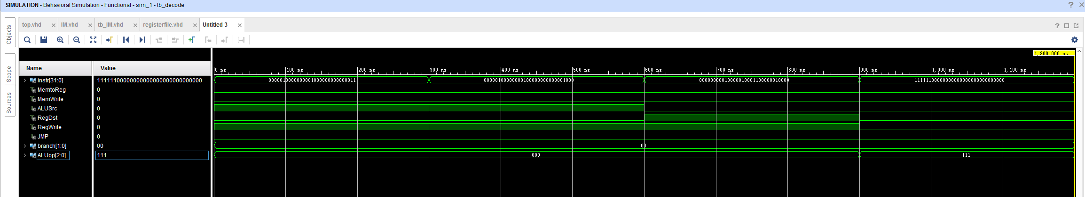
11111100000000000000000000000000 --HAL // HALT

the simulation of register file:
input instruction also comes from the example part 1 code which have 4 instructions, the input of ALUSrc, RegDst, RegWrite comes from the same time output of the decoder simulation up above.
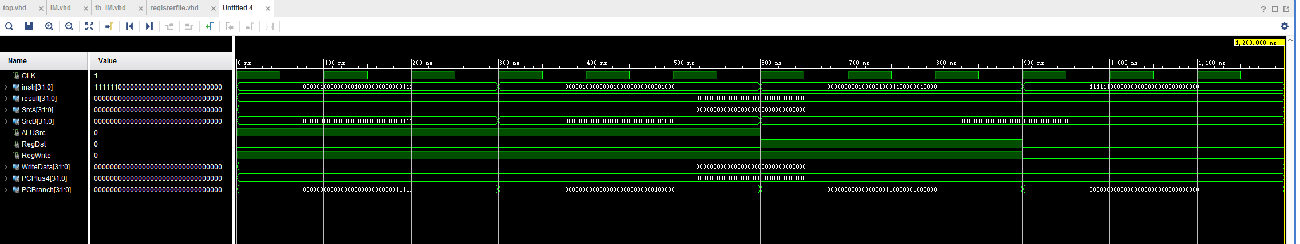

the simulation of Instruction Memory
as described in the project requirement, the IM module is used to restore all the instruction needed to be executed in correct order. In this simulation, the instruction is set to the part 1 sample code.
